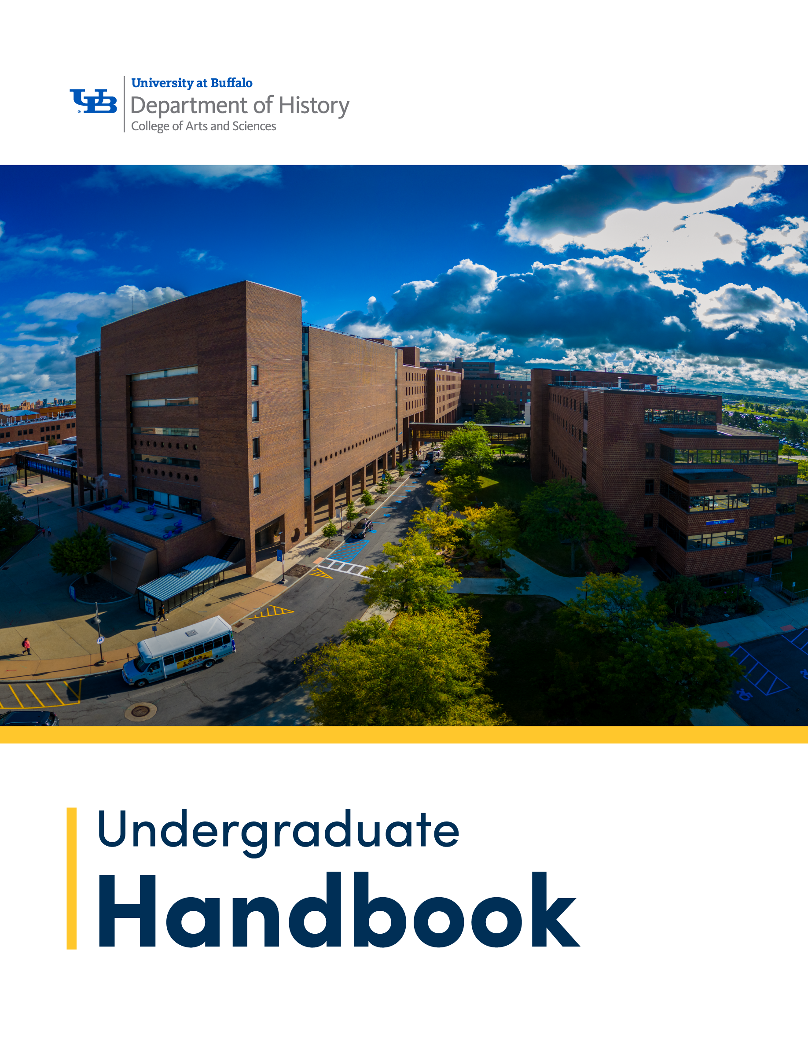

# Department of History Undergraduate Handbook

# Undergraduate Handbook

## Core Faculty and Staff

**Kristin Stapleton**

**Department Chair**

525 Park Hall | 716- 645-5645 | [kstaple@buffalo.edu](mailto:kstaple@buffalo.edu)

**Andreas Daum**

**Director of Undergraduate Studies**

570 Park Hall | 716- 645-8421| [adaum@buffalo.edu](mailto:adaum@buffalo.edu)

**Jennifer Darlak**

**Graduate and Undergraduate Studies Coordinator**

543 Park Hall | 716-645-3433 | [jmdarlak@buffalo.edu](mailto:jmdarlak@buffalo.edu)

**Michelle Burger**

**Department Administrator**

537 Park Hall | 716-645-8400 | [mlb@buffalo.edu](mailto:mlb@buffalo.edu)

**Amy Christensen**

**Office Administrator**

546 Park Hall | 716-645-2282 | [amychris@buffalo.edu](mailto:amychris@buffalo.edu)

## Introduction

This handbook serves as your essential guide during your time in the Department of History at the University at Buffalo (UB). Inside, you’ll find information about programs, policies, advising, and opportunities for academic and professional growth. For additional questions, contact your Advisor, the Undergraduate Studies Coordinator, or the Director of Undergraduate Studies.

## Program Overview

The Department of History offers diverse courses in a welcoming environment. **History students** develop skills in critical thinking, research, and communication while examining the evolution of societies and global connections. Students learn to ask “what happened” and “why” to better understand today’s world.

### Why choose UB?

* Accomplished scholars as your primary instructors
* Individual mentorship from faculty
* Balance between large and small class environment
* A departmental Honors Program (different from UB Honors College)
* Opportunities to pursue individual research projects
* Prizes and scholarships for undergraduates
* Support for study abroad programs
* Perfect fit with Finish in Four

### What can I do with a History degree

A degree in history prepares students for careers in:

* Journalism, law, education, government, and military service.
* Business, politics, museums, cultural organizations, and non-profits.
* Communications, public relations, and archival management.

Skills developed include **critical thinking**, **creative problem-solving**, **research**, and **effective communication**. The [**American Historical Association**](https://www.historians.org/resource/careers-for-history-majors/) provides additional career guidance for history majors.

### Incoming students

Incoming students and undergraduate transfer applicants who are interested in pursuing a BA in History or a Minor in History must first apply and be accepted to UB. Students who have identified History as their study area will be listed as History majors at the time of acceptance. Students entering the University may declare History as their major upon entrance or switch to the major at any point by following the steps above. Visit [UB Undergraduate Admissions](https://admissions.buffalo.edu/) for all relevant information, including admissions criteria, the online application, dates and deadlines, and standardized test score requirements.

### Current students

To request to change to a Major or a Minor in History, please complete the [CAS Major/Minor Change Request](https://arts-sciences.buffalo.edu/advising/academics/change-majors.html) form to request one of the following changes to your academic plan:

* Add a major, minor, or certificate in the College of Arts and Sciences
* Drop any major
* Drop any minor

## History BA

Acceptance Criteria  
Minimum GPA of 2.0 overall. Exceptions at the discretion of the Director of Undergraduate Studies.

Advising Notes  
A minimum grade of C- is required in any course for it to count toward graduation requirements. A minimum GPA of 2.15 in history courses is required to graduate.

Required Courses  
Twelve history courses (36 credit hours) distributed in accordance with the level and breadth requirements described below are required. You must take a minimum of eight upper-division courses (300-400 level), including at least two 400-level seminars. There are no prerequisites for progression through the history major, but history students are encouraged to take lower-level courses prior to taking upper-level ones. Students are also urged not to take two 400-level seminars in the same semester. Students should consult with their assigned Advisor and the department’s Director of Undergraduate Studies when planning their course of study.

### Level and Breadth

To ensure a broad knowledge of history, all history majors must take at least one course, at any level, in each of the following areas:

* Early or early modern history of any civilization to 1800 (PRE)
* Asian, African continent, or Latin American history of any period (AAL)
* Modern European history since 1800 (EUR)
* U.S. history of any period (USH)

A course that seems to fall into two breadth areas may be used to satisfy the requirement of one. Advanced Placement and International Baccalaureate credit will not count toward the 36 credit hours required for the major. However, AP credit (with a score of four or better) in U.S. or European history, or I.B. credit (with a score of four or better) in U.S., European, African, or Asian history, can fulfill breadth requirements.

Courses with grades of Satisfactory under the S/U option (elected by the student) or Pass under the P/F option (designated by the instructor) cannot be used toward the fulfillment of course requirements for history majors.

A course used to fulfill a requirement for a double major, joint major, or a minor in another subject may not also fulfill a requirement for the history major.

Transfer Policy  
Transfer students majoring in history may receive credit for up to five history courses (15 credit hours) but must take the two required 400-level seminars at UB. Whenever possible, transfer courses are articulated with existing UB history courses. Acceptance criteria and all other requirements are the same as for regular majors. Students may transfer up to two history courses (6 credit hours) for credit toward the minor. Transfer students should come to the undergraduate studies office for advisement even when placed in the major upon enrollment at UB.

## History Minor

Acceptance Criteria  
Minimum GPA of 2.0 overall.

Required Courses   
You must complete 18 credit hours (normally six, 3-credit courses) with a minimum grade of C- required in each course intended to count toward graduation requirements.  
A minimum of 3 of these must be upper-division courses (300-400 level).

Advising Notes  
A minimum grade of C- is required in any course intended to count toward graduation requirements.

Courses with grades of Satisfactory under the S/U option (designated by the student) or Pass under P/F option (designated by the student) are not acceptable in fulfillment of the course requirements for history minors.

A course used to fulfill a requirement for a major or minor in another subject may not also fulfill a requirement for the history minor.

There are no prerequisites for progression through the history minor, but history students are encouraged to take lower-level courses prior to taking upper-level courses. Students should consult with their assigned Advisor and the department’s Director of Undergraduate Studies when planning their course of study.

Up to three history courses at the 100/200 level may be counted toward the minor requirements. Recommended courses include HIS 113, [HIS 142](https://catalog.buffalo.edu/courses/?abbr=HIS&num=142), HIS 143, HIS 144, [HIS 161](https://catalog.buffalo.edu/courses/?abbr=HIS&num=161), [HIS 162](https://catalog.buffalo.edu/courses/?abbr=HIS&num=162), and [HIS 182](https://catalog.buffalo.edu/courses/?abbr=HIS&num=182). It is recommended that these courses be taken in either the first or second year. Students may transfer up to two history courses (6 credit hours) for credit toward the minor.

## Combined Programs

UB offers three other academic programs that are connected to the Department of History:

### Combined History, BA / Social Studies Education, EdM

The UB Teach social studies education program is an accelerated, combined degree program that allows students to earn a history BA and a social studies education EdM in five years. The program focuses on providing students with content expertise in history while preparing them to teach social studies at the adolescence level (grades 5 to 12). For more information, contact the [Department of Learning and Instruction](https://ed.buffalo.edu/teaching/academics/ub-teach/history.html).

### School of Law 3+3 BA/J.D. Accelerated Program

The School of Law recognizes that qualified undergraduate students have the capacity and readiness to complete their undergraduate education and their law degree in less time than the seven years of study typically required. Through this program, students complete B.A. and Juris Doctor (J.D.) in just six years of full-time study, saving students one year’s worth of time and tuition. Prospective students may select the “3+3” combined degree major or “3+3” on their application for undergraduate admission into the program (supplemental materials may be required). First-year and second-year undergraduate students may meet with their advisor to discuss their options for entry into the program. For more information, contact the [School of Law](https://www.law.buffalo.edu/admissions/3-plus-3.html).

### History/School Librarianship, BA/MS Program

This combined degree program offers history students the unique opportunity to enhance their undergraduate studies with specialized graduate coursework in School Librarianship. This comprehensive program equips students with the knowledge and skills required to obtain state-certified K-12 teacher librarian credentials, enabling them to embark on rewarding careers as K-12 teacher librarians in school library settings. Students completed a B.A. and a M.A. degree this is American Library Association accredited program in five years rather than the traditional six years, saving time and money on their education. For more information, contact the [Department of Information Science](https://ed.buffalo.edu/information/academics/combined/history-sl.html).

## Scholarships and Awards

The Department of History has been fortunate to benefit from bequests and donations that support our undergraduate students. Our scholarships reward academic merit, commend strong character and work ethic, aid underrepresented minorities, and support students’ study abroad plans. We are grateful to those who provide the means for students to focus on their core academic studies and gain international experiences.

### Milton Plesur Scholarship/ Department of History Scholarship

Full-time history majors who have compiled outstanding records in history are eligible to apply for a Plesur Scholarship (also called the Department of History Scholarship), named after Professor Milton Plesur (1927-1987). Professor Plesur devoted his career to teaching and bequeathed his estate to the university for the continued of Awards will be made to students who can demonstrate the most serious interest in and commitment to history as evidenced by academic record, extra-curricular activities, and career plans. A sophomore awardee who continues to compile an excellent record in his or her junior year may reapply for a second year of support for the senior year.

### Bryan G. Argo Memorial Scholarship

History majors who are residents of Niagara or Erie County and full-time students in their junior or senior year and working at least part-time who have compiled an over-all grade point average of at least 3.0 are eligible for the Bryan G. Argo Memorial Scholarship. This award is made each year through the generosity of the family and friends of Bryan Argo, a history student who was devoted to family and friends, believed strongly in continuing education, and whose promising life was tragically cut short. The scholarship awards demonstrated family values, integrity, and personal achievements. Applicants should submit a letter of reference from a current professor or civic or spiritual leader and write a personal statement as described in the application.

### Joyce J. and John D. Milligan and Family Scholarships

Full-time history majors from underrepresented minorities, with good academic credentials and personal characteristics (attitude, personality, citizenship, and leadership) are invited to apply for a Milligan Scholarship. This scholarship is made available through the generosity of John D. Milligan, a long-time Department of History faculty member, his late wife Joyce who served the Department as a secretary, their daughter Jacqueline, a dedicated teacher of English as a Second Language at UB, and two other daughters, Elizabeth and Polla, both residents of Buffalo.

Awards are made to rising juniors and seniors annually. Preference will be given to African-American students from Western New York who have financial need. The junior award is renewable in the senior year at the discretion of the chair of the Department of History.

### Department of History Undergraduate Diversity Scholarship

We are excited to support students who can demonstrate that they contribute to the diversity of the student body, especially those who can show that they have overcome a disadvantage or other impediments to success in higher education. The Department will award up to eight Undergraduate Diversity Scholarships for students entering their Sophomore, Junior, or Senior year.

### Department of History Internship Scholarship

The Department of History believes firmly in the value of experiential learning and public history as fundamental to the experience of our majors. The Department offers scholarships for students enrolling in the Department’s Internship course, HIS 496. The Department’s Public History Internship course allows our students to explore the many and diverse ways in which history is put to work in the world, complementing their class work with valuable, hands-on experience in museums, historical societies, cultural or preservation organizations, and non-profits. The Department of History Internship Scholarship recognizes the value of the internship by establishing a competitive award for students engaging in projects with particularly strong public history merit. In addition to the General Application applicants will also need to submit a letter of recommendation, a personal statement, and a brief description of the merit of their intended project.

### Milton Plesur and Schoellkopf Awards for Study Abroad

Each year the Department of History awards study abroad scholarships to qualified History majors enrolling in a recognized summer, semester, winter intersession, or year-long study abroad program. The department holds a competition in the fall for spring semester study abroad and one in the spring for summer, fall, and full academic year programs.

### Undergraduate Research Paper Prize

At the end of each academic year, the Department awards a prize for the best honors thesis or substantial research paper written in that academic year. The prize is awarded in honor of Professor Patricia Mazón, a historian of Germany who retired from the department in 2017. The author of the winning paper will receive a cash prize and will be recognized at graduation.

### Curvish Paper Prize

History majors in their senior year who have written an outstanding paper relating to the U.S. Constitution are invited to apply for the Curvish Paper Prize. The Edward L. Curvish, Jr. Award was established in 2000 by Edward L. Curvish, Jr., who received a BA in the Department of History. He went on to receive a Master’s in Education and taught high school for many years.

### Early Recognition Awards

Each winter the department gives out awards to undergraduate students who have demonstrated an exemplary commitment to historical writing and research in a HIS 301 Seminar or a 400-level History Seminar during the previous fall semester, as demonstrated in an outstanding seminar paper. Faculty may nominate one student per seminar; self-nominations or applications are not possible. Both History Majors and Minors may be nominated, and there is no preference for a particular group of students or particular topics. The Early Recognition Awards do not include a financial compensation or scholarship. Recipients are recognized through a certificate and an announcement on the department’s website and social media.

### Milton Plesur and Schoellkopf Awards for Study Abroad

Each year the Department of History awards study abroad scholarships to qualified History majors enrolling in a recognized summer, semester, winter intersession, or year-long study abroad program. [Study abroad scholarship forms](https://arts-sciences.buffalo.edu/history/undergraduate/scholarships-awards.html) are available online. The department holds a competition in the fall for spring semester study abroad and one in the spring for summer, fall, and full academic year programs.

Two other funding opportunities for study abroad:

* [College of Arts and Sciences Study Abroad Scholarship](https://www.buffalo.edu/educationabroad/projects/financialplanning/scholarships.html)
* [U.S. State Department Gilman International Scholarship](http://www.iie.org/Programs/Gilman-Scholarship-Program)

### Additional Scholarship Opportunities

The College of Arts and Sciences (CAS) also maintains a list of [Undergraduate Scholarships & Awards](https://arts-sciences.buffalo.edu/academics/undergraduate/funding-your-degree.html) available to undergraduate students within the College.

Before filling out the general application form, carefully read the descriptions and requirements for the scholarships and awards you are applying for. Most scholarships require documentation in addition to the form such as a personal statement or project description. These additional required documents can be uploaded directly to the online form. Please read the instructions on the application carefully.

Contact [UGhis@buffalo.edu](mailto:%20ughis@buffalo.edu) if you have any questions or concerns about completing the online form.

## Experiential Learning

### Finding an Internship

Contact a historical organization of your choice in consultation with the Director of Undergraduate Studies. You may pursue internships outside WNY. The Director will approve eligible internships and give permission for force-registration in HIS 496.

### Independent Study

Research opportunities outside the departmental Honors program are also possible through Independent Study and Research (HIS499) with a faculty mentor. Students should seek advisement with the Director of Undergraduate Studies who can help to identify suitable mentors.

### Study Abroad

History is a natural major when pursuing studies outside the USA. To support study abroad, the department offers yearly scholarships to those attending accredited programs. The Director of Undergraduate Studies will review study abroad course offerings with students to select courses that satisfy student interests and fulfill requirements.

## History Honors Program

The History Honors Program (different from UB Honors College) offers students additional opportunities for intellectual exchange and individual research. Honors students participate in an advanced fall seminar (HIS 497 I) and produce a substantial thesis based on their own primary source research in the succeeding spring semester (HIS 497 II). Majors who have completed at least four history courses with a minimum grade point average (GPA) of 3.33 (B+) or who have a letter of support from a faculty member willing to supervise their project are eligible to apply for admission to the Department of History Honors Program.

Applicants to the program will need to submit a [Department of History Honors Program Application](https://arts-sciences.buffalo.edu/history/undergraduate/honors-program/HonorsApp.html). Upon admission to the program, honors students are responsible for arranging with a faculty mentor to guide their thesis research and writing. Honors students who complete the thesis and maintain a minimum GPA of 3.33 in the major will graduate with Honors in History.

## Phi Alpha Theta logo.

## Phi Alpha Theta

[Phi Alpha Theta (PAT)](https://www.phialphatheta.org/) is the national honor society for students in the field of history, with 860 chapters on college and university campuses across the nation. Membership is a mark of intellectual accomplishment and commitment. Phi Alpha Theta students also have the opportunity to present their research at an annual regional conference. At UB Phi Alpha Theta hosts events such as game nights and field trips and more. Current members are eligible for leadership positions as well. If you are interested in one of these positions, please contact the Phi Alpha Theta Advisor, [Dr. Cari Casteel](mailto:caricast@buffalo.edu).

### Requirements for PAT Membership

Undergraduate students must complete a minimum of 12 semester hours (4 courses) in History, achieve a minimum GPA of 3.1 in History and a GPA of 3.0 or better overall. A maximum of 3 credit hours of online, transfer, or AP credits may be applied to the membership eligibility requirements. All graduate students who maintain a 3.5 GPA are eligible for membership after the completion of their first semester.



## Undergraduate History Association

The Undergraduate History Association is a club for anyone interested in history—majors or not! We cultivate a safe, fun environment to enjoy the subject through various games, lectures, and events. A great opportunity to connect with fellow student historians and be a part of the campus community. The club meets on a weekly basis during the Fall and Spring semesters.

Direct any questions to Club President, Fiona Serrano: [fionaser@buffalo.edu](mailto:fionaser@buffalo.edu)

## Courses

Course offerings by the Department of History vary from semester to semester, allowing students to explore different historical topics while working towards their degree. The diverse course catalog gives students the opportunity to take courses of their own interests, while also laying the foundation for a vast base of knowledge, aligned with the Level & Breadth requirements. See below for the three ways to access course descriptions and schedule information:

### UB Degree & Course Catalog

To view the complete archive of HIS courses, prospective and current students may view the public [Degree & Course Catalog](https://catalogs.buffalo.edu/preview_program.php?catoid=1&poid=137). This website outlines where courses fall within the History BA degree requirements and offers other useful UB catalog information, which users can access through the various search features on the left side of the page. Please note that these descriptions do not reflect course offerings in a particular semester, but simply it outlines the courses that have been offered in past semesters.

### Public Course Schedule

To view HIS courses offered in a given semester, prospective and current students may view the [Public Course Schedule](https://www.pub.hub.buffalo.edu/psc/csprdpub/EMPLOYEE/SA/c/NUI_FRAMEWORK.PT_LANDINGPAGE.GBL?tab=DEFAULT). By clicking on the “Course Schedule” icon, users may access current and upcoming Terms and use the “Search” tab to find “HIS” course offerings. Upon searching, users may use additional filters on the left side of the page to narrow down the results.

### Course Schedule Viewer

Current UB students may view HIS course offerings for the upcoming semester through the [Course Schedule Viewer](https://arts-sciences.buffalo.edu/advising/academics/course-schedule-viewer.html). By using the search filters at the top of the page, users can view HIS courses. The website is updated on a nightly basis to accurately reflect registration data.

## Student Resources

### Students in Difficulty

Students with any academic or personal difficulty that may interfere with their schoolwork should talk to the Director of Undergraduate Studies, or to their CAS Advisor. Additionally, the [University Counseling Center](https://www.buffalo.edu/studentlife/who-we-are/departments/counseling.html) at 120 Richmond Quad offers free and confidential counseling.

### Accessibility Resources

Students with disabilities are encouraged to visit the university’s [Accessibility Resources Office](https://www.buffalo.edu/studentlife/who-we-are/departments/accessibility.html) at 60 Capen Hall for consultation. Students might qualify for certain accommodations to help them satisfy academic requirements.

### Tutoring & Academic Support Services

Students in need of tutoring or academic coaching can utilize the resources available in the [Tutoring & Academic Support Services (TASS)](https://www.buffalo.edu/studentsuccess/tutoring.html) office located in 130 Capen Hall.

### Career Design Center

Located at 259 Capen Hall, the [Career Design Center](https://www.buffalo.edu/career.html) assists students in areas of self-assessment, career exploration, internships and job searches across all fields of study.

### Academic Integrity

The University at Buffalo takes very seriously its commitment to principles of academic integrity as foundational to the enterprise of teaching and learning. Our academic community expects the highest ethical behavior on the part of our students in the completion and submission of academic work. Regardless of whether instruction is in-person or remote, it is every student’s responsibility to complete their work in an honest fashion, upholding both the expectations of their individual instructors as well as the university’s broader academic integrity policy. Only through these practices can students maintain their personal integrity and ensure UB’s tradition of academic excellence. Students should review the [Academic Integrity Policies](https://www.buffalo.edu/academic-integrity/policies.html) with the [Office of Academic Integrity](https://www.buffalo.edu/academic-integrity.html).

### Academic Advisement Report (AAR)

The Academic Advisement Report (AAR), accessible through [HUB](https://www.buffalo.edu/ubit/services/all/hub.html) at the Academic Requirements tab, tracks student progress through UB and the major requirements. Students should check it every semester, and if any discrepancy if found, to speak with their assigned Advisor.

### Other Resources

* [Department of History website](https://arts-sciences.buffalo.edu/history.html)
* [Student Advisement and Services](https://arts-sciences.buffalo.edu/advising.html)
* [International Student Services](https://www.buffalo.edu/international-student-services.html)
* [Student Success Resources](https://www.buffalo.edu/studentsuccess/resources.html)

## Contact Information

Visit the Department of History website for more details or contact [UGhis@buffalo.edu](mailto:UGhis@buffalo.edu) with questions about scholarships, resources, and advising.

This handbook is your roadmap to academic success—explore the exciting opportunities UB’s Department of History offers!